Wireshark Lab

# First task

* Activated and running. 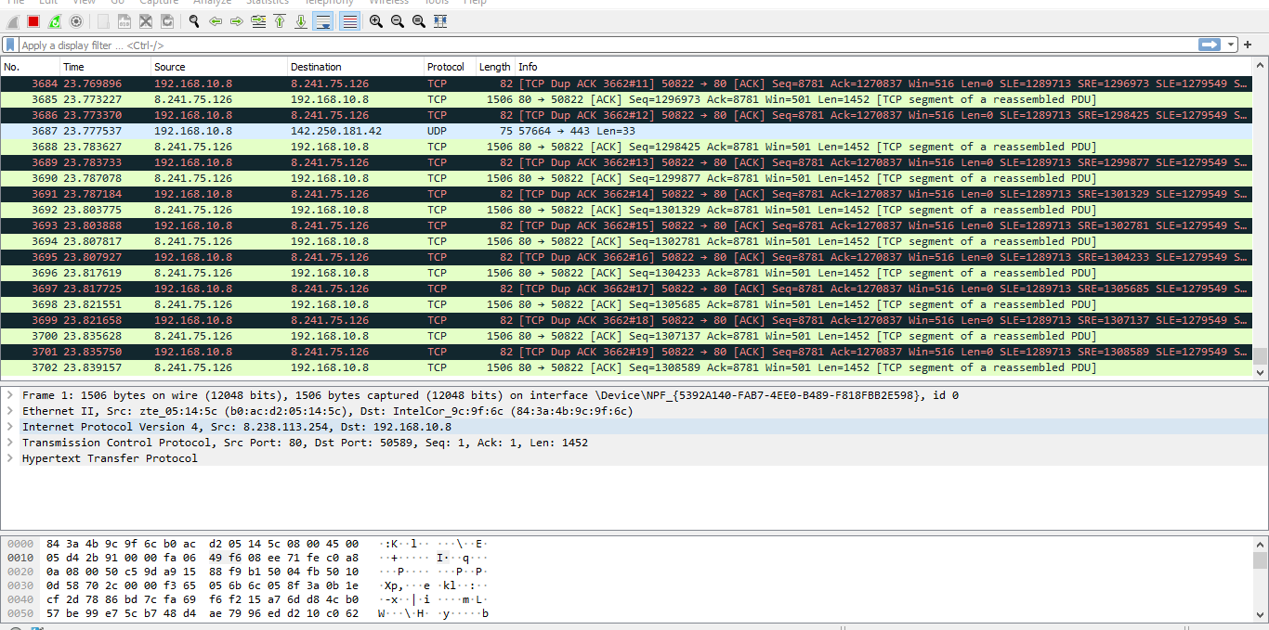
* Http filtered packets. 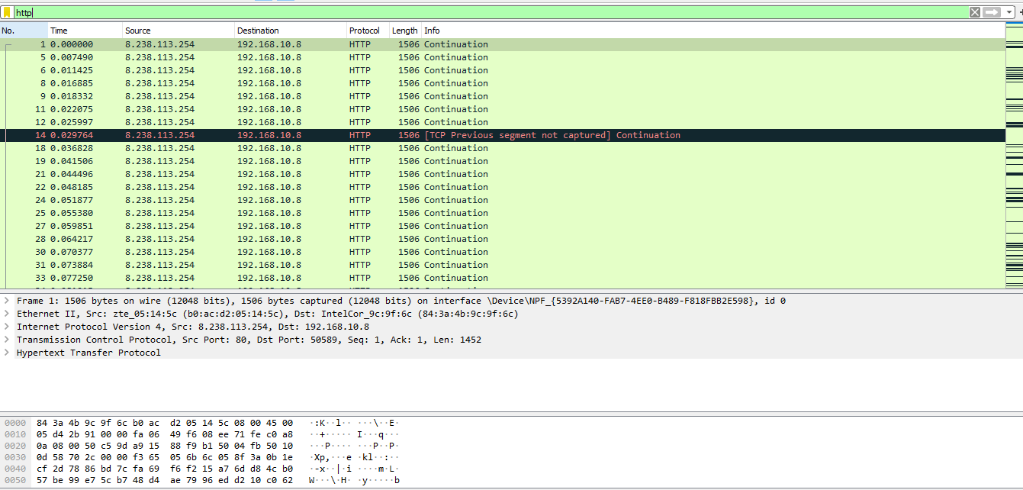
* Viewing specific domain packets. 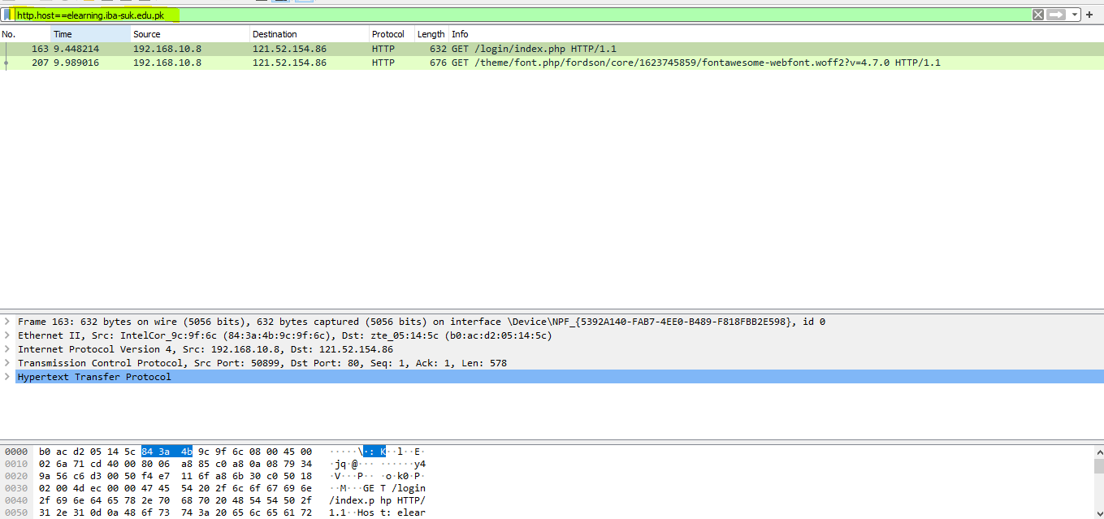
* DNS protocol. 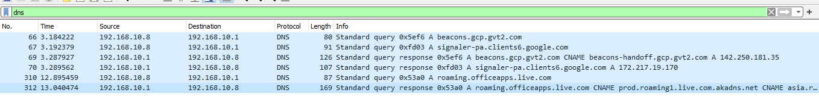
* Viewing UDP stream. 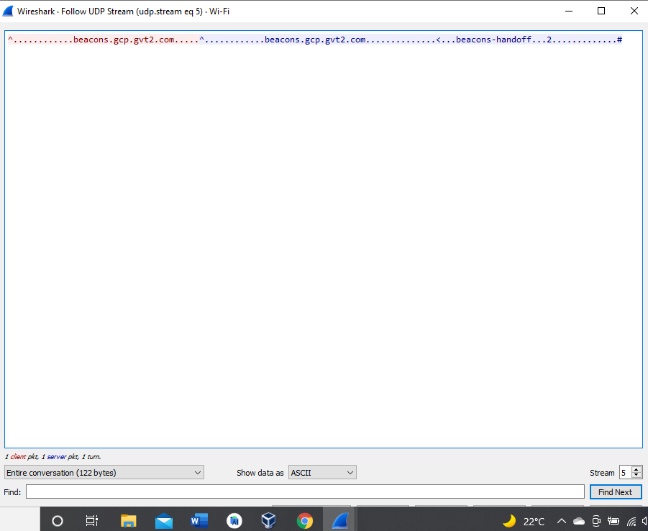
* Viewing TCP stream. 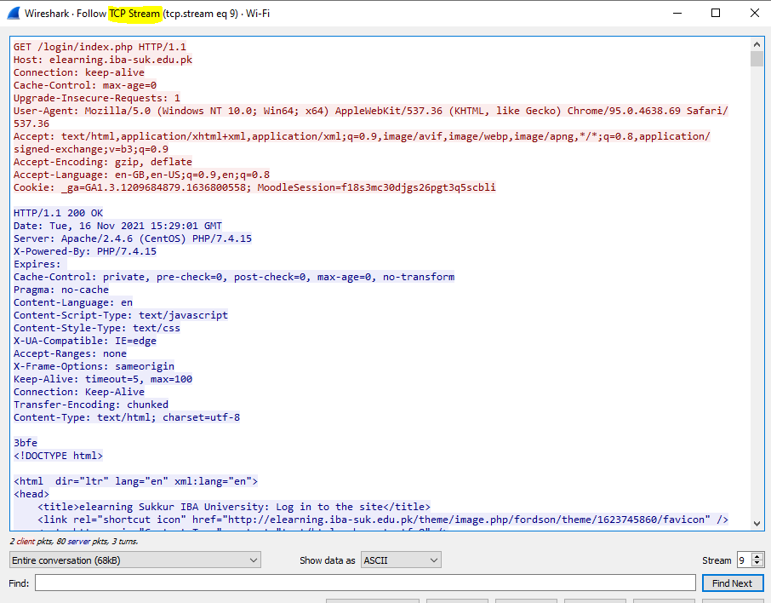

# Task two:

When packets are marked by black color, that means the packet is incomplete or problematic or was damaged while been sent over a network.

# Task three:

For the traffic that is being send over a network from our system is viewed using HTTP command,

http.accept (FOR ALL THE RESPONSE SENT OVER BY SYSTEM TO SERVER) 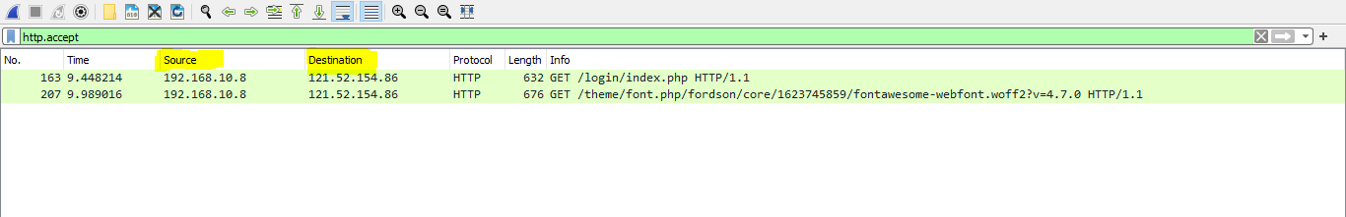

# task four:

UDP (user datagram protocol) is used for video streaming as its faster and it’s not a secure protocol use plain text streaming. This protocol is also used for DNS queries as DNS queries are only consist of IP-address lookup, for that encrypted data is not needed.

HTTP (hypertext transfer protocol) is responsible for transfer of webpages over a network form server to the machine requesting. Http uses TCP (transmission control protocol) for communication as it is reliable, it makes sure the data is sent to the requested machine all packets are send properly and it has this functionality of reporting if packet is lost, dropped or crashed and request for that packet again. Where in UDP case if some packets are lost during video transmission it does not affect the outcome or streaming.